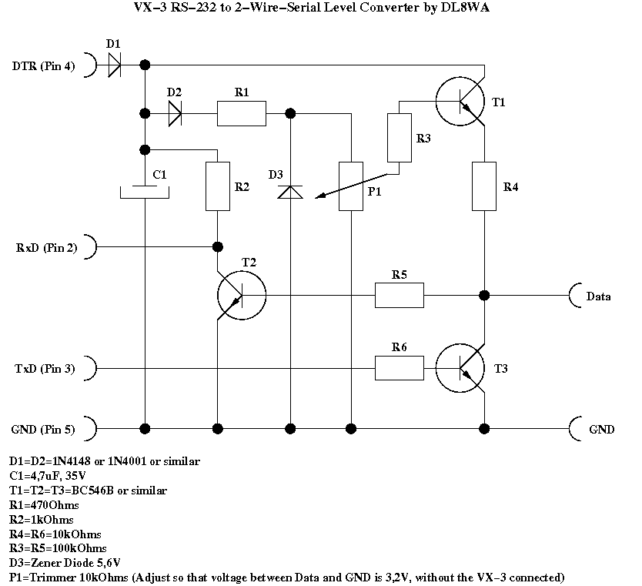
Short circuit description:

Safety advice: Kids, do not try this at home.

If you built this interface, you do it on your own risk. If you barbecue
your PC, your transceiver or anything in between including yourselves,
this is your problem! You should only built this interface if you're
sufficiently familiar with electronics. I reject any liability or
responsibility in case of damages of whatever kind - you have been warned!

I have tested the interface with a Prolific USB-to-RS-232 converter on
the PC side, and both a Yaesu VX-3 and an FT-60 transceiver, and it
works fine for me. A test with a Yaesu FT-7800 is soon to come.

The interface is fairly standard and made from parts that any decent ham
should have at home:

The supply current for the interface is drawn from the DTR line of the
RS-232 via D1. T2 together with R2 and R5 is a simple switching stage
that converts the 3,3V signal level from the transceiver to the
RxD-level. T3 with R6 acts as a pull-down switching stage for TxD.

The new thing is the decoupled, adjustable pull-up voltage that has been
realized using D2, R1, D3, P1, R3 and T1: It stabilizes the pull-up
voltage independently of the RxD and Txd-levels, different from many
other interfaces. The RxD voltage is around the voltage that DTR
delivers because it is decoupled by D2, and thus should match any serial
line. The pull-up voltage for the transceiver's two-wire interface can
be adjusted from 0-5V using P1, so that you can match almost any voltage
level. R1 has been dimensioned so that the stabilisation circuit works
with a DTR voltage greater than 7V. The voltage between Data and GND
must be adjusted to around 3,3V for my VX-3 (measure it without the
transceiver connected).

The diodes in my interface are standard 1N4001 because I had these at
hand. Any other standard diode, including 1N4148, should do the job. The
same applies to the BC-546B-transistors - they are standard small-signal
NF NPN-transistors in a TO-92 package, but I suppose any other standard
NPN type should be ok. If you intend to exchange the 5,6V Zener diode
with something else, please keep in mind that you have about 0,6 V
voltage loss in the T1-stage, and that the voltage delivered by DTR
might also be limited, especially on USB-to-serial adaptors, so I
suggest that you stick to the value of 5,6V as close as possible.

The pin numbers given are those for Sub-D-9-plug RS-232 lines. If you
have the older 25-pin plugs or anything else the pin numbers will vary!

Good luck & vy73, DL8WA

